Volume 4, Day 1: Who Does God Help?
“God helps those who help themselves.” That only makes sense. Or does it? When we ask God to help us heal a physical ailment, does He give us surgical skills and tools to perform medical procedures on ourselves? “NO!” Does He just bolt out of the blue and heal our sickness? “NO!” Is God obligated to heal us? “NO!” Is God an unloving parent when He does not give us what we want? “NO!”
Then, why do we get angry with God when we do not get the healing we think we deserve? Well actually our anger is unfounded, and yet common to most of us, for two reasons. First, what we deserve is nothing. “There is none righteous, NO, not one.” “All of my righteousness is as filthy rags” to God. Secondly, God purposely allows in His wisdom that which He could easily prevent by His power.
Who does the surgeon help? Does he help those who help themselves? “NO!” Does the surgeon even ask you to assist him? “NO!” The physician performs his healing work on those, and only those, who agree that he is needed, he is the chosen one and he has WRITTEN PERMISSION from them to perform his work on them!
So, it follows then, even from our own experience in life, that God only helps those who will humble themselves and LET GOD DO HIS HEALING WORK! So if you have ever, and most of us have, been angry with God because He would not help you, APOLOGIZE for your arrogance. REPENT of your arrogance. [ REPENT means to change your mind about what you believe, in this case about who needs who and who really does the job. ] Admit that you are not the physician, but you are a willing recipient. And for sure, humble yourself under his skillful hand. God only helps those who admit that they need to be fixed. And God’s primary fixing, is the fixing of the soul. And the soul that is ‘fixed’ is the soul that rejoices in adversity and pain knowing that God IS love and can be fully trusted to have a ‘divine’ purpose in everything in the life of that soul.
Volume 4, Day 2: “… by His Stripes We Are Healed”
Does Isaiah’s statement, “… by His stripes we are healed,” mean that we obtain physical healing by Jesus’ brutal beating and inhumane crucifixion? I implore you to consider this. What exactly did God have in mind when He designed the brutal, humiliating, massacre of His ONLY BEGOTTEN SON? Did God let Himself, in the person of His Son, be the most unfairly treated of all beings, human or divine, in order to heal our physical infirmities? Or did God create this heinous criminal act on the part of mankind in order to heal our ‘selfish, corrupt, hurtful’ souls?
If you claim to be a Christian, I would hope that you would exclaim that, “Jesus died to save the ungodly from eternal separation from God.” Did Jesus live the perfect life, which we could not, only to die a criminal’s death so that we could be more comfortable (prosperous), more highly respected (popular) or more worshipped by and in control of others (power)? Again, “NO!” That would be ridiculous. Yet, that is what we want and what we pray for.
Our anger with God and all others is sourced in our own childish self indulgence. We ask God to fix this or do that. We expect Him to take away all of our misery. We expect Him to define ‘good’ in the same manner as we define ‘good.’ But, scripture clearly declares that GOD defines ‘good’ as GOD HIMSELF. “GOD IS LOVE!” is a direct quote from His written Word. God’s definition of ‘good’ is anything that fulfills His purposes. His purposes are always in the best interest of ridding His creation of evil and redeeming all who are willing to be in a perfect relationship with God.
Jesus, as the embodiment of God’s love, humbled from the highest glory to the lowest human experience, did not “…lay down His life for His friends” in order to serve their selfishness. He died so that they too could (and would) die to selfish ambition and be redeemed forever.
My Confirming Scripture: My Aligning Experiences:

Volume 4, Day 3: Have A Good Day
I discovered while substitute teaching in my county that some schools are much easier to teach in than others. I was tempted to select just the easy schools and avoid the difficult ones. But as I reflected on the gospel, I realized that it is needed most by the most troubled people. The gospel is about wholesome relationship. And it is breaking relationship that creates the difficulties that plague our school system.
So rather than avoid the difficult schools, I simply chose the first available assignments and let God lead me to where he wanted me to teach. When I would walk into a school where the students were most challenging, I would often hear this from an administrator as I signed in to teach, “We hope you have a good day today.” This came from a sense of guarded hesitation and expectation of the opposite. My response was always the same, “Oh, I will have a good day. I never let anyone choose otherwise for me!”
By the time the Holy Spirit called me to teach in the public school system, after having retired from a successful career in high tech, I had reached new heights in my relationship with God. I had discovered that my happiness could be found in his presence within me in the midst of the most difficult relational carnage I encountered. It is ever only and always when I remain aware of the presence of the Almighty in my soul that nothing can trouble me. Rather than being agitated or upset, I feel grief and sorrow for the relational brokenness I see, hear and feel.
If you are a believer in Jesus Christ, the Holy Spirit doesn’t walk beside you behind you or in front of you. He resides within your soul. He could be your soul mate if you would but remind yourself constantly that He is present. He accepts you on your worst day as much as on your best day and wants nothing but the best for you. The day may be filled with turbulence and difficulty, but your awareness of His presence provides peace in the middle of any and every storm.
Pour the best within you, His enormous affection, on everyone around you and you will have a good day!
Volume 4, Day 4: The Sin of Responsibility
When does acting responsibly become sin? You might retort, “Are you nuts? It is never a sin to act responsibly.” And, to be sure, you are in agreement with most people. We strive to teach our children to be responsible and contributors to the common good of our own community. We discipline them so as not to spoil them. And we often help them begin their adult journey with financial and other help. We are proud of them if they become successful in their chosen vocation and if they build friendships with others who are responsible as well.
Many also encourage others to be part a some religious order and to practice the teachings of the chosen religion in a responsible manner. In this case we might call it acting responsibly toward God. Yet we can, and often do, cross the line into sinful behavior. God’s Law defines sin as: “breaking relationship to serve selfish purposes.” We can act responsibly according to man’s laws, mores of our society, or even our appointment calendar, while we are breaking relationships all around.
The ultimate problem is when we fail to teach and practice an up-close-and-personal relationship with God. The highest order of obedience is obedience to what God wants us to do in the moment. When God’s Spirit reveals something which He wants us to do, and we fail to do it, for any reason, being responsible to anything or anyone other than God is sin. We actually do our children a grave disservice if we fail to teach them to be responsive to God rather than responsible to any person. “…Thy will be done, on earth as it is in heaven…”

My Confirming Scriptures:

My Aligning Experiences:
Volume 4, Day 5: Law or Love/ Letter or Spirit
Wrap every rule in its reason.
Then use the rule in its season.
If it’s peace that you want,
then the rule you won’t flaunt.
You’ll apply it by only its reason.
Here’s what I do, when a rule’s in my way.
I use its reason that lets me play.
But you, my friend, if you try this too,
I’ll use the rule as a club to beat you.
You always must play it my way.
I have a reason for each rule I break.
And to me it makes sense, make no mistake.
If you’d simply give me benefit of the doubt,
I highly suspect that you would find out,
the same rule you’d break,
if you swam in my lake. — J. H. Alan
Laws, man’s or God’s, are written and enforced as a matter of safety not mindless restriction or constraint. It is because of the affections we have and the desire to live safely in community, that we create laws at all. Yet much of the division and conflict within a society is created when we fight over the letter of the law versus the spirit of the law.
The first 4 of the 10 Commands of God are about breaking relationship with God and the last six are about breaking relationship with people. So when you are tempted to resist the constraint brought by law, consider that the purpose of that law is to promote healthy, affectionate relationships (love). Then attempt to comply with it in the spirit (reason) which it was established.
Jesus summed up God’s 10 Laws as, “Love the Lord your God with all your heart, soul, mind and expression, and to love your neighbor as much as you love yourself.” Mark 12:30. But, to His own disciples He gave His Own new command, “Love each other as much as I have loved you.” (Jesus was willing to die for the safety of all, even His enemies.)
Volume 4, Day 6: Make Love Not War
In the ‘70s a popular expression was “Make love, not war.” It was a pacifist statement made in repulsion of an unpopular war in which the United States was engaged. However the implications of the expression have a positive impact across the board. Obviously, when we love others, we are not likely to engage in violent arguments or fights with them. Yet, we mostly find fault with others and criticize their words or actions! Why on earth would we push people away from us, especially the ones we most want to be with?
Obviously, most of our negative expressions are directed at people or activities which we think are wrong or unfair by our own definition of good and evil. Yet we tend to lose sight of the fact that other people often have opinions which are different from our own which are not necessarily wrong. Actually, if we are intellectually honest, we must admit that there are no two people whose opinions or beliefs are completely the same. And the most foundational of all tenets of relationship is a mutual acceptance of the diversities as well as the similarities of others.
The one thing that is most common to all people is the desire to be accepted and embraced by others. A smile and a hug go a long way to brighten our day. And the more we accept others, just as they are without changing their opinions or behaviors, the more we will be accepted by others in the same way.
There is FREEDOM from animosity and angst in simply accepting the things which we cannot change. And to be sure, we cannot change anyone else. We can’t even change ourselves. Only our Creator can change us but He will not do so, unless and until we admit to Him that we need to be changed and give Him permission to do so.

My Confirming Scriptures:

My Aligning Experiences:
Volume 4, Day 7: Habit or Personal Desire
Do you have religious practices, such as going to church, feeding the hungry, providing shelter for the homeless, or giving to charity? Do you have predictable activities in which you engage or songs you might sing or books you might read? Is it possible that even what you do in worshipping God is the same week after week?
Why would I think that God would be happy with my monotonous routines? Aren’t we made in God’s image in order to be in relationships with each other and with God Himself.? Maybe it’s time to become up close and personal.
I was in church with my family from the time I was a few days old. My parents were so religious that they took me several times a week. I learned the Bible stories, I memorized scripture, I said the prayer for salvation in Sunday School at age six and as an early teen even led in worship with my music teacher. But I reached the point when I didn’t want to go to church any more, but would not admit it.
When I was 14, an evangelist came to our church to conduct a revival. I don’t even remember what he preached about, but his messages kept my attention. After the last meeting, I went to meet the evangelist and thank him for his good sermons. But I was caught off guard when my pastor put his arm around me and asked, “You’re going to be a preacher too, aren’t you? Not wanting to be embarrassed, nor to embarrass the pastor, I replied, “If God wants me to, I will.” As I lay in bed later, God spoke to me in my thoughts. “Did you tell the pastor that you would be a minister if I asked you to?” “Yes,” I replied. He continued, “Did you mean that?” I said “No!” I quickly recoiled in fear that He might strike me for lying to the pastor. In the loud silence that followed, I asked myself, “If God cares enough about me to meet me up-close-and-personal in my own room, why wouldn’t I do anything He asked of me. So I said, “I’ll say it again now and this time I mean it!” My heart flipped as I fell in love with God and was truly born again. Never again did I go to church just for appearances sake. I loved God’s house!
Volume 4, Day 8: Passion
The human heart moves us by emotion to do nearly, if not everything, we do. We become people pleasers in order to receive the admiration of others. We do things for applause and recognition. We often do even dishonest things in order to be accepted in one crowd or another. This happens in every aspect of our lives. Yet, many of us feel as though we cannot be our true selves and still be embraced by others. And in many cases we are correct. Many people only hang out with others of like mind or talent or vocation.
The quest of humanity pulls us in myriad directions. Yet we long to be free from the tyranny of the should of others. And we make this even worse by tyrannizing those around us with our opinions and shoulds. All the while the secret longing to be loved “as-is” with no changes, goes unsatisfied as we continue to hide behind what we think are expressions which will endear us to another.
One thing that is common to all humanity is the desire to be the object of another’s passion. We know that those we treat the best are the ones we care deeply about. We may not realize, however, that we are the greatest obstacle to finding the love we crave. We tend to be negative and critical. At the same time we expect others not be return that negativity. Is this not a bit less than sane?
The crux of the Gospel is that Jesus’ passionate love for us compelled Him to suffer our punishment. He did not give up His life as the noble or right thing to do. His love for us is nothing short of passion! God likely suffered even greater agony than Jesus, in watching mankind brutally beat and crucify His Son naked on a cross.

. 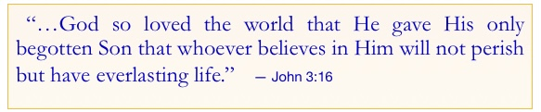

Volume 4, Day 9: Faithful: the Fire of Desire
Many people pursue a life of virtue. And virtuous living is respected by all. It tends to give us a sense of goodness. And it certainly helps us live peaceably in community. There are banners in most schools and places of worship with words of character. Yet with all of this, the focus on the what-to-do aspect of character rarely gives one those traits. We can manage our behaviors by sheer determination, but ultimately we run out of strength and fail in one area or another. The song lyrics below are an example of the religious version of the character for living to which most of us subscribe.
There is a general consensus about the behaviors which are to be sought after in order to treat each other well. However, the missing piece of the puzzle is the how-to-be a person of character. We are born with a healthy sense of self. We are taught to look out for number one or no one else will. Yet this need to protect, prosper, promote and be powerful is often the very thing that causes us to fail in our attempts to be persons of character.
When we exchange the fire of our devotion for the fire of desire for relationship with one another, good character becomes a by-product of our love. In short, genuine affection (love) for another compels us to do good to them. The more you love them, the less likely you are to hurt them!

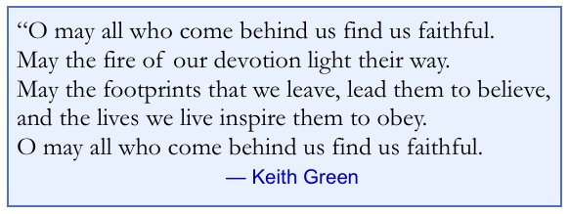
Volume 4, Day 10: Sin Defined by Love
There was a time, not too long ago, when darkness was defined as the absence of light. We have discovered through science that darkness is a substance of its own. But for the sake of simplicity, let’s use the original thought as a pattern for defining sin. To many, there is no such thing as sin. But if we define sin as “having my needs or desires met by anything that causes harm to another,” likely all would admit to having done this more than once. In a similar fashion we might also say that “hatred is the absence of love” or “rejection is simply the absence of acceptance.” We could go on with several of these analogies. This simple paradox of opposites, by count of such expressions in a person’s life span, account for the lion’s share of human experience.
Let us consider the simplest of paradigms. Let’s look at life as a stream of events which are either/or on the scale of emotions. This might be over simplifying or trivializing life itself. But if we observe our interactions with each other from the perspective of various shades of either/or we might find that anything less than the most positive feeling toward others is also sin. If we consider anything less than the highest positive feeling will hurt them, we can only remedy the problem of wrongful behavior by achieving the most loving feeling for others. Without God’s help, this cannot happen.
God’s commands were summarized by Jesus as “Love God fully and love your neighbor as much as you love yourself.” This has been boiled down today to say, “Love God. Love Others.” But Jesus’ example and command was even more difficult to obey. Jesus’ only command to His disciples is, “Love others as much as I love you!” — John 13
Consider this. Sin is anything less than an unconditional love for God and others! If you are sinless, raise your hand!

My Confirming Scripture: My Aligning Experiences

Volume 4, Day 11: “Be Angry and Sin Not…” - Part 1 of 10
Anger arises in the soul, when a specific emotion has been ‘hurt.’ Anger management is what the scripture calls for. However, you cannot manage anything which eludes your understanding. Simply screaming expletives or striking out at others can only be curbed when we determine what triggers our outburst. Anger management requires “discovery through analysis” of the root emotion which causes these extreme expressions (anger as a weapon of manipulation or warfare). God’s way: Jesus Christ was treated more unfairly than any other human being! Yet, Jesus did not strike back!!!
I separate anger from emotion since I now know that anger is the volume of expression that indicates that some underlying emotion is being hurt. I found my way out of my anger prison by letting God reveal the specific emotion that was hurt and letting him heal that wound permanently. After several emotions were resolved and released to his care, I released the rest of them on the same basis. Anger is the result of my insistence on having my emotional desires satisfied.
But then you ask, “What about Jesus’ anger expressed toward the religious leaders of his day?” Okay, then, “What about it?” To be sure there were several occasions when the Pharisees were verbally corrected by Jesus! However, we tend to think that He did it with malice. He did not! Jesus’ “righteous” anger was neither punitive nor malicious! His retorts were necessary to set the expression of truth straight. Jesus never expressed Himself strongly toward anyone over opinions that differed from His. He definitively set the record straight because our lives and eternal destinies were at stake! Jesus could not let falsehood stand just so that He would not offend or embarrass anyone. Jesus’ anger was not directed at people. His anger was directed at false teachings that would hurt His people.
Jesus even asked His Father to “forgive the Pharisees who crucified Him and mocked Him as He died…for them too!” Thus Jesus was angry and did not sin! Love like Jesus Loves and you will be angry and NOT sin!!!
Volume 4, Day 12: “Be Angry and Sin Not…” - Part 2 of 10
Anger arises in the soul, when and only when, some other emotion has been hurt. Anger management is what the scripture calls for. However, you cannot manage anything which eludes your understanding. …
Most people have likely heard that you should count to 10 before you respond when you are angry. And some can do that and actually refrain from expressing their hurts violently (with anger volume). However, in my experience, most people cannot do that. Most will have already verbally or physically reacted before they can count to ONE.
I was personally involved in a counselor training session where this issue was being addressed. As the leader moved in the direction of “wait” before you express anger, the Holy Spirit whispered to me. This will not work with you, so listen to the teacher with one ear while I teach you what you must do. After all, John Henry, in retrospect you will see that you have always immediately reacted (responded) before you even thought about what you were expressing or why! I admitted that this is true of me and others with a similar personality.
[ADMITTING the truth about myself is essential.]
This is what the Holy Spirit revealed to me, “John Henry, when someone kicks your can over, what spills out is what is in your heart. Since you spill out immediately without thinking, you need to change the contents of your heart such that what spills out is ‘love and compassion’ rather than your ‘self-serving attitude’ (acids, toxins, poisons, hurtful stuff)”. This made perfect sense to me. And it will also work with the 1 to 10 counters who manage to remain inexpressive. Actually, it works best for all because a loving expression is always cathartic. Silence may be golden, but it cannot compare to caring encouragement. So I embarked on a quest to remove the hurtful stuff and replace it with the ‘Love of God.’ Try it! You’ll like it!.

My Confirming Scriptures: My Aligning Experiences.
Volume 4, Day 13: “Be Angry and Sin Not…” - Part 3 of 10
Anger arises in the soul, when and only when, some other emotion has been hurt. Anger management is what the scripture calls for. However, you cannot manage anything which eludes your understanding. …
So now you ask, “How exactly did you, or could I, eliminate the hurtful, normal human reactivity and replace it with a love which is not natural for us?” Thanks for asking! Unless and until you ask this question and sincerely desire to make this exchange, you will continue to hurt those who hurt yourself or those near you.
Let us ponder for a moment the manner in which we change anything we do. Everything we do is based on feelings. We may have developed habits which express themselves even when we don’t think about it. However, those habits were formed initially by our reaction to some feeling. Repetition makes it happen seemingly automatically, but it began in response to a hurt feeling. [Let me clarify ‘hurt.’ Hurt means to damage or distort something. When that something is a ‘feeling,’ we immediately set about to correct the damage or distortion.] So in order to manage my angry responses to hurt feelings, I need to isolate the specific feeling and how that feeling became sensitized to the stimulus that triggers my rage (expressed as verbal or physical retaliation or silence or inaction but a definitive rejection of the source of the stimulus).
As we explore ourselves by identifying memories which have pain (embarrassment, inconvenience, and so forth) associated with them, we can uncover why we react, when others might not, to the same stimulus. As God’s Spirit enlightens us as to why we feel hurt (a specific emotion), we can surrender that to Him. Once surrendered, peace ensues and freedom from that particular hurt in the future. If we refuse to surrender it to God, we will writhe in misery and continue to rage on!
My Confirming Scriptures: My Aligning Experiences:
Volume 4, Day 14: “Be Angry and Sin Not…” - Part 4 of 10
Anger arises in the soul, when and only when, some other emotion has been hurt. Anger management is what the scripture calls for. However, you cannot manage anything which eludes your understanding. …
Many psychologists believe that anger is NOT a feeling. Rather it is a strong (maybe even violent) expression of ‘hurt’ feelings. I personally believe that Anger Management is a valid pursuit, only because anger is NOT an emotion, but rather an exacerbated expression in reaction to fear or pain. To that end I have been able to help many overcome anger (that is ‘sin’ which follows outbursts of anger). You cannot manage feelings. They are as natural and unstoppable as breathing. But you can change feelings. And this is why.
Relationship is a ‘feeling’ business. Rationale is an ‘efficiency or expediency’ business. There is a progression in humanity regarding all expressions between beings. The progression follows this pattern. Feelings follow beliefs. Thoughts follow feelings. Actions follow thoughts. Therefore, every expression of human beings begins with what they believe. And beliefs can be changed by choice. And choices are affected by new understandings.
Children may be afraid of ‘boogey men’ or ‘ghosts’ and so forth. But once they understand that there is no such thing, the associated fear goes away, forever! So consider the possibility that your over reaction in anger might very well be triggered by a wrong belief. Consider also that much of what you believe is relative truth because you learned it from your relatives and their circle of influence. Children are great recorders of events, but often lousy interpreters of these events. For example, my Sister and I have the same parents who treated us alike. She thought they were abusive (until a few years before she died) while I thought they were terrific parents!

Volume 4, Day 15: “Be Angry and Sin Not…” - Part 5 of 10
Further exploration of the progression from the ‘abundance of the heart’ (belief) to the ‘mouth speaking’ (expression) reveals useful information which can and does lead to ‘transformation’ (greater love and acceptance of others) through a renewing of the mind (change in beliefs) as written in Romans 12:2. Learning this progression, ‘from the heart to expression, helped me affect changes such that when my cup is kicked over, healing love pours out instead of my caustic opinions and misguided understandings. I had received most of what I believe from ‘well-meaning’ family and friends. Yet, the Bible is the only trustworthy source of God’s truth as revealed to us by the Holy Spirit’s guidance to truth (John 16). Most of us have accepted many things which are only partly true and some things that are completely false!
I began to analyze each angry expression in order to discover what belief I held had been hurt (rejected). I first considered what feeling was involved. Once I had isolated the feeling, I asked myself why another’s expression (word or action) ‘hurt’ that particular feeling. I asked God to reveal what I needed to change in my beliefs in order to eliminate the ‘hurt’ feeling. I did this repeatedly until the belief was changed or dismissed and the feeling ceased to be ‘hurt.’
In 3 years, I had changed over 300 misperceptions into the reality of God’s perceptions. The statement, “Your perception is your reality.” became a constant awareness in my mind. And if you don’t think this statement is true, consider the need for asylums for people whose perceptions are so far from reality that they must be contained for their own protection and the protection of those around them.
Let God’s Holy Spirit “guide you into ALL truth…” which is His purpose in the life of the believer in Jesus. If you have trouble hearing His voice, be patient, He will ultimately guide you to the truth you need to know and enable you to make adjustments to what you believe. You can trust God NOT to misguide you on any issue on which you confer with Him!
Volume 4, Day 16: “Be Angry and Sin Not…” - Part 6 of 10
Anger arises in the soul, when and only when, some other emotion has been hurt. Anger management is what the scripture calls for. However, you cannot manage anything which eludes your understanding. …
“…out of the abundance of the heart the mouth speaks.” (Matt. 12:34) The progression mentioned in a previous day’s message might be restated as, “What my spirit chooses to believe, when that belief is challenged or affirmed, creates a feeling {negative or positive}, which my mind ponders with regards to how to express my displeasure or my pleasure and then my body expresses those thoughts.” We are “made in the Image of God.” The four aspects of God’s image in which we are made are: CHOICE, COMPASSION, RATIONALE and EXPRESSION. Our ‘free will,’ ‘desire,’ ‘sense of justice’ and ‘purpose for communicating’ correspond to God’s ways. With the HEART we choose beliefs. With our SOUL we feel. With our MIND we think about what course of action or words we will use. And with our STRENGTH (body) we express ourselves (do or say). Jesus actually described this imagery in the Gospel of Mark.
In Mark 12:30 Jesus describes the likeness of humans in the image of God is having 4 unique parts:
Heart – Soul - Mind - Strength (expressions: word or action)
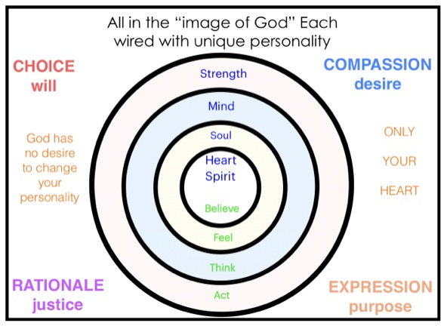
Volume 4, Day 17: “Be Angry and Sin Not…” - Part 7 of 10
Anger arises in the soul, when and only when, some other emotion has been hurt. Anger management is what the scripture calls for. However, you cannot manage anything which eludes your understanding. …
One aspect of anger which is seldom considered is that most anger directed at people has beneath its noisy or violent expression some anger toward God as well. After all, most people believe that God could prevent evil from happening or bad things from happening to good people. In retrospect I could see that nearly all of my prayers were asking God to do something for me like taking away problems, or filling my pockets with money. And when God did not answer my prayers with a resounding ‘yes’ and in short order, I was at least a little bit displeased. Most of my prayers up to that point were asking God to do good things and eliminate bad things (as I defined them).
So then, when processing ‘anger management’ techniques, which in this case is diligently striving to change the negativity in my soul into positivity toward myself, others and God, I should strongly consider if and why I might be mad at God Himself. It is likely that I am asking God for things which will not serve His purposes for me.. To that end, this volume of devotional messages includes a series on ‘prayer.’ Our pursuit of a ‘clean’ heart must include dialog with God in every moment of decision. You may even find that you have ‘some’ anger toward God in ‘every’ angry expression.
The most common anger is about one’s sense of fairness having been violated. Now, to be sure, most of us have a similar sense of fairness. But when we do not, it creates conflict of the highest order. Wars are mostly fought over religion or politics, both of which are matters of opinion. But flying in the face of our pursuit of fairness is the fact that Jesus was treated the most unfairly of any human who ever lived. Therefore praying for ‘fairness’ is not God’s desire. Praying for God’s purposes to be fulfilled is most consistent with His desire.
Volume 4, Day 18: “Be Angry and Sin Not…” - Part 8 of 10
Anger arises in the soul, when and only when, some other emotion has been hurt. Anger management is what the scripture calls for. However, you cannot manage anything which eludes your understanding. …
In order to affect changes in your motives you must first know what your motives are. We often hate in others the motives we cannot stand in ourselves. But we rarely notice that our opinions of others mostly assume that everyone else is like me, warts and all. So, when you are judging another person, snag that criticism and be introspective with it. It well could become a scalpel which will perform exploratory surgery, as it were, on your spirit (motives). And it is highly likely that all of this exploratory surgery will be painful.
When you dissect an angry expression and isolate the ‘hurt’ emotion and tie it to something you believe, you are prepared for ‘heart’ surgery. This can be performed with the assistance of a counselor (heart specialist) or with only the assistance of God, the ultimate physician, especially of the heart. The first step is to ask yourself, “Is my anger directed toward another person(s) or toward God?” If the answer is ‘both,’ process the anger toward another person separately from your anger toward God.
ANGER TOWARD GOD: Ask yourself,
“Why are you expressing anger toward God?” and
“What is it that I believe about what was just said or done that caused this particular emotion to be ‘hurt?’

REMEMBER: Be specific as to the emotion not the expression (anger).
ABOUT THE BELIEF: Ask yourself,
“Not that it is true, but does my belief ‘feel’ true?”
Then, present that belief to the Lord and pray,
“LORD, what do You want me to believe instead of what I do now?”

It is God’s Holy Spirit who can correct your beliefs! Just let Him do it!
Volume 4, Day 19: “Be Angry and Sin Not…” - Part 9 of 10
Anger arises in the soul, when and only when, some other emotion has been hurt. Anger management is what the scripture calls for. However, you cannot manage anything which eludes your understanding. …
ANGER TOWARD ANOTHER PERSON: Ask yourself,
“Would you have any hesitation about expressing the opposite of anger?” and
“What do you believe would happen if you did the opposite behavior?”
The answers here should help you determine the reason for your angry expression (words or actions). The reason will be a belief which you have.
REMEMBER: Be specific as to the emotion not the expression (anger).
ABOUT THE BELIEF: Ask yourself,
“Not that it is true, but does my belief ‘feel’ true?”
Then, present that belief to God and pray,
“LORD, what do You want me to believe instead of what I do now?”
It is God’s Holy Spirit who can correct your beliefs! Let Him do it! Often the Holy Spirit takes you to a Scripture which expresses a belief that will bring you relief. It may be another verse you memorized which brings with it a belief contrary to the one you held which precipitated your behavior (angry expression).
I found it most helpful to assume that what I had been believing needed to be changed. Jesus, never had a bad thought about people. He had an unfailing compassion and understanding of their emotional needs. He loves without conditions of behavior or motive. That is what His life, death, resurrection and ascension are all about.
Volume 4, Day 20: “Be Angry and Sin Not…” - Part 10 of 10
In summary, anger management is directed by God’s Word, but only applied by my choice. Blaming others for my ‘hurt’ feelings is counter-productive. It is only the truth about myself that will set me free. When I am free from all fear, pain, embarrassment and all other self-focus, I am free indeed!
All of my ‘hurt’ feelings boiled down to playing to the wrong audience. My concerns about pleasure, prosperity, popularity, reputation, power and control being found in a human audience caused every ‘hurt’ feeling! When I began playing to an audience of one, God, who loves me always and without conditions of behavior or motive or results, all ‘hurt’ feelings vanished.
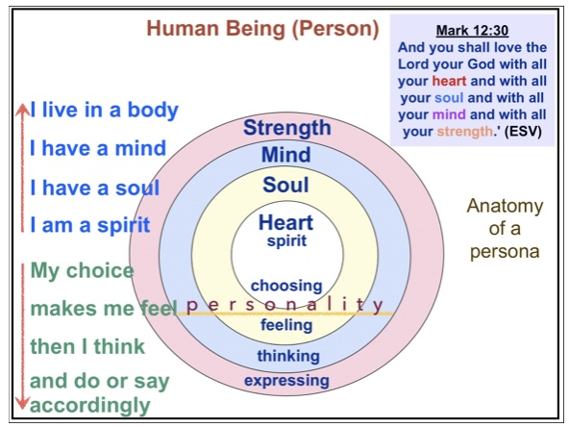
Although I sort of backed into the truth of God’s Word using this practice to manage my anger by filling my heart with love, joy and peace, at least I discovered the truth is clearly stated in Galatians 5:16 “This I say then, Walk in the Spirit (of God) and you will not fulfill the desires (p, p, p, r, p, c above) of the flesh (my spirit). Notice the progression from choice of belief to expression. It will either be dictated by my spirit or God’s Spirit. It is my free will choice to do it myself or “let God” do it in every experience of life!

I now make a cognitive choice in every encounter to surrender my choice to the Spirit of God.
His beliefs bring
His feelings to bear such that
His thoughts will specifically craft
His loving expression!

My Confirming Scriptures: My Aligning Experiences:
Volume 4, Day 21: Eliminating ‘hurt’ One Emotion at a Time
We are spiritual beings, driven purely by emotions. We cannot change our emotions, but we can change beliefs which affect them. Our anger or euphoria, madness or exuberance depend on the choices we make as to what we believe. And what we believe can be changed by choice. The ultimate in personal peace, pleasure and healthy relationships begins with a hot pursuit to understand what God believes and resonate with His heart. The pattern is obviated by our human relationship with our most significant other. When God becomes our most significant, we will have been fully redeemed and our selfishness will have been replaced with His unconditional and unselfish caring.
The chart below may help you to identify emotions which are easily ‘hurt’ so that you can process the anger with God and eliminate each ‘hurt’ emotion. You can test each new belief against the truth of scripture so as to insure healthy change.

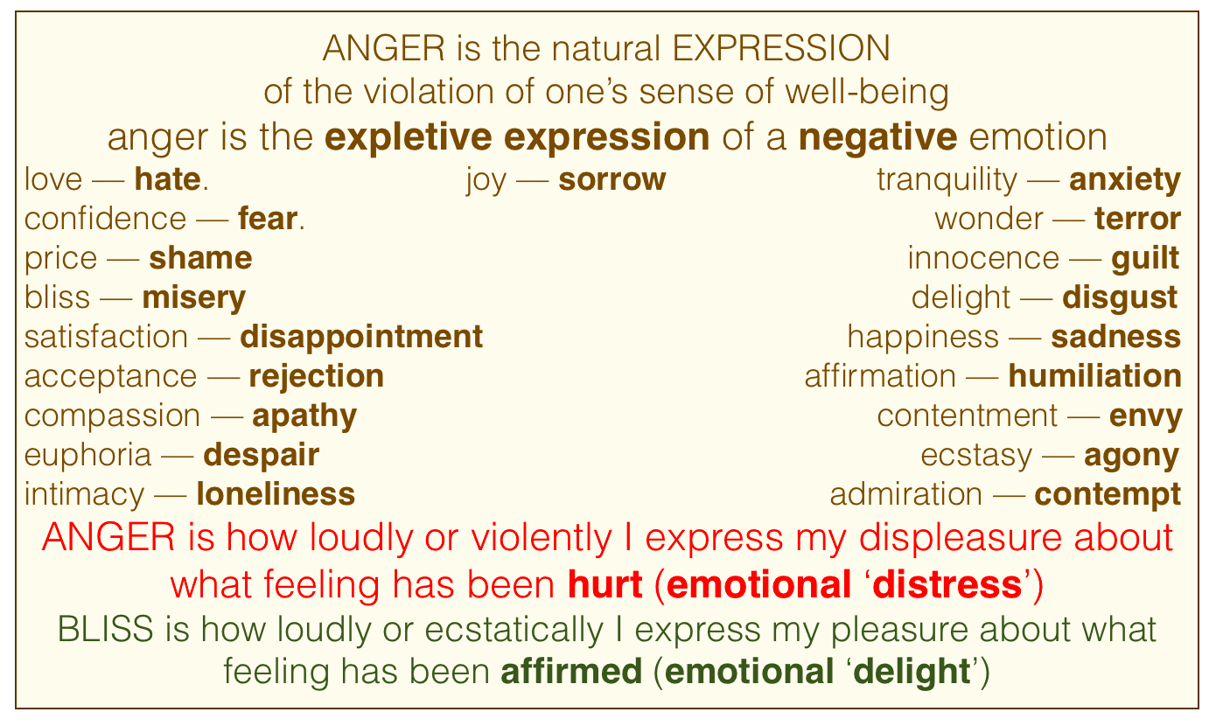
My Confirming Scriptures:

My Aligning Experiences:

Volume 4, Day 22: Anatomy & Physiology of Addiction 1 of 5: CAUSE
Addiction is a world-wide web of epidemic proportions. It affects more lives than any physical plague or virus ever has. There are rehabilitation centers everywhere. Yet this blight on humanity prevails. There will never be a vaccine or cure invented by mankind. But, wait on it! Wait on it! … Addiction is far more widespread that most have formerly believed. It affects many who do not even recognize it.
The progression of the addiction cycle begins with STRESS of any sort which hurts our emotions. The inherent problem with rehab, is that once completed and the participant is thrown back into the pond, when the stress returns, so does the addictive expression. Even the ‘poster child’ rehab graduate would be likely to relapse were it not for the shielding of the recovered person from the stress of normal life when they are absorbed into a stress free position within the rehabilitation program center.

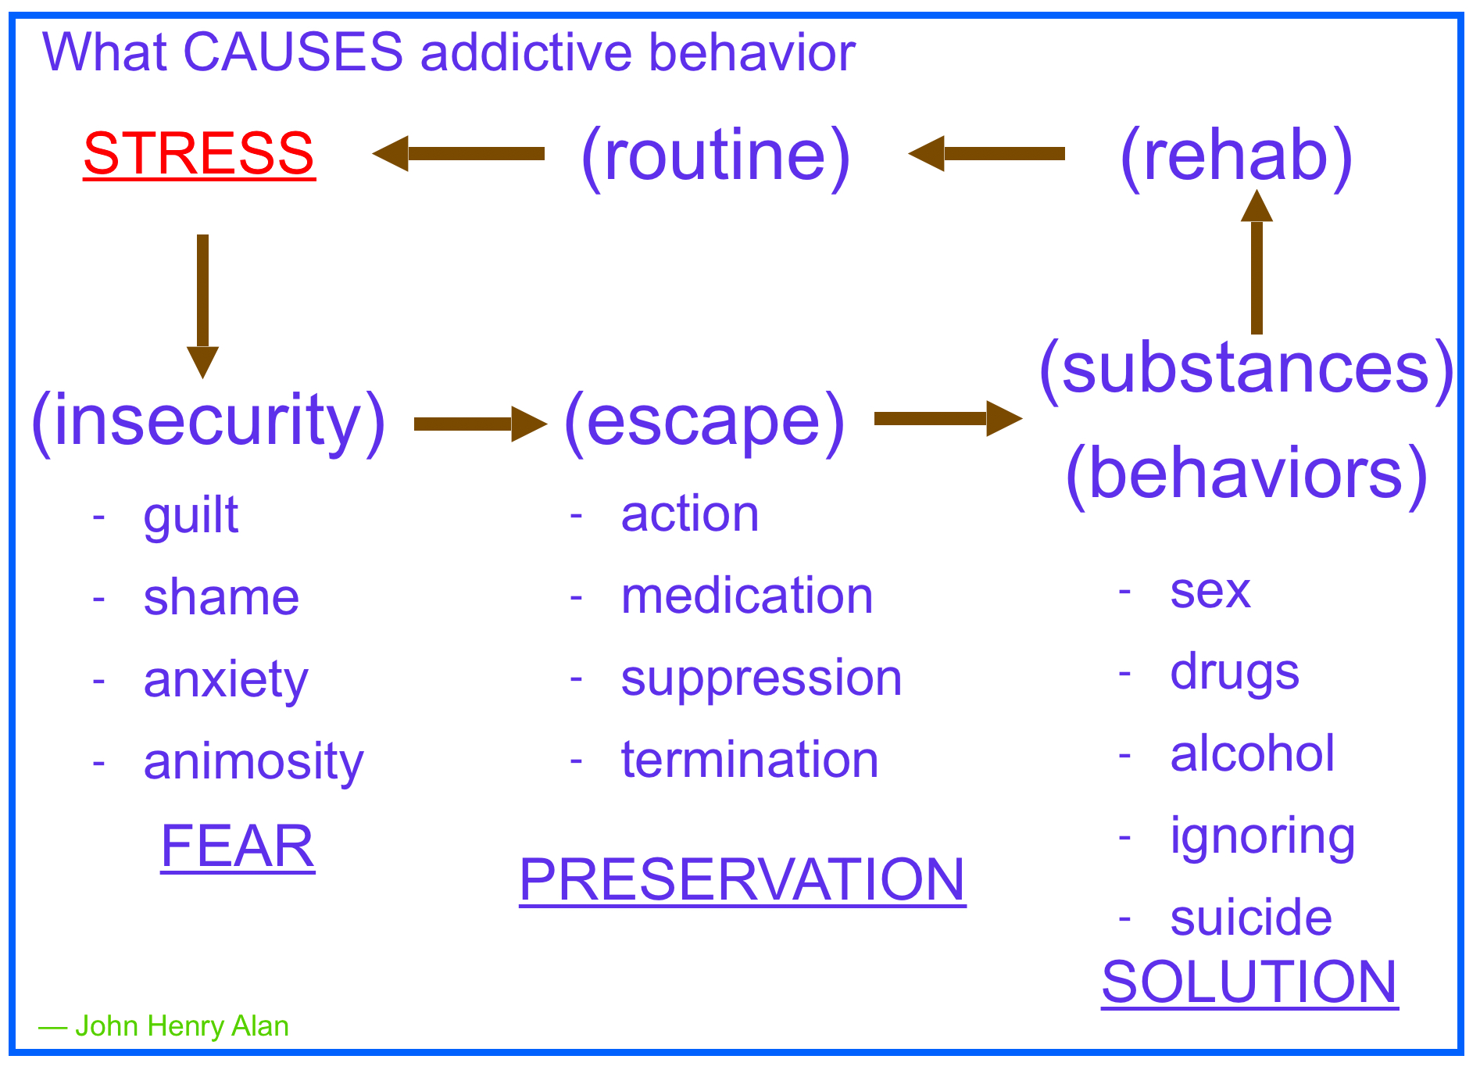

Vol. 4, Day 23: A & P of Addiction part 2 of 5: INSECURITY
Following the CAUSES diagram in Day 22, when STRESS hits us, we feel INSECURE. Insecurity is most often associated with feelings such as guilt, shame, anxiety and animosity. In a word, FEAR overwhelms us. Human nature is self PRESERVATION which causes us to seek an ESCAPE from that which scares us. Usually our means of escape is by way of activity, suppression (denial), medication or, if severe enough anxiety, even termination. Next we choose some substance or behavior to relieve the pressure. Largely we resort to sex, drugs, alcohol, denial, service (activity / busyness), or suicide.
After we have wallowed in our stupor long enough we will try to get back on track through some form of rehabilitation. Regardless of the means by which we get the substances out of our bodies or the behaviors under control, we somehow begin to function normally again.
After a few weeks of successful engagement with our routine, we may conclude that we have been cured. However, when the pressures of routine life pile high enough, we embark again on another cycle of addiction. Then we, and those who surround us with concern, engage together in another round. But is there a solution, a more permanent solution? Some might say, “Just come to Jesus as you are and He will solve you!” Unfortunately, although there have been some whose salvation experience brought complete healing, most Christians are miserable and susceptible to this diabolical cycle for much of their lives.
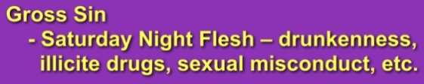
Take heart, there is an explanation for Christian addiction and a permanent solution. And ‘wait for it!’ The permanent solution may not be the eliminating of the cycle at all.

My Confirming Scriptures:

My Aligning Experiences:
Vol.4, Day24: A & P of Addition part 3 of 5: RESPONSIBILITY
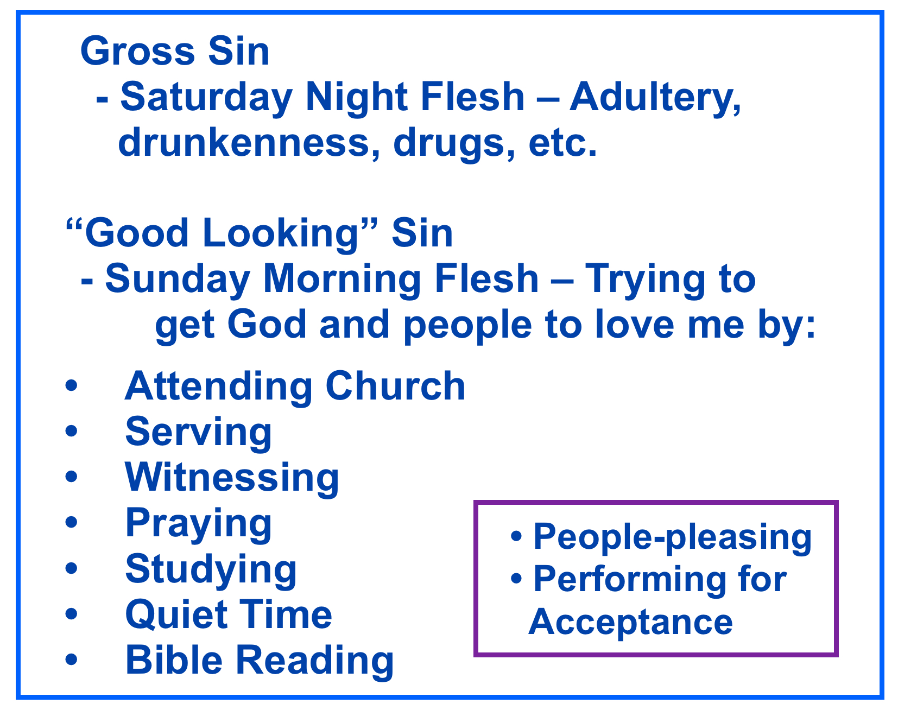
It is easy to spot the one who is addicted to irresponsible stuff. Christians might call these the Saturday Night Live version of additive expression. But, few Christian’s recognize the Sunday Morning (Church) or just plain responsible (socially acceptable) ones. Consider this. Addictive behaviors are common to all humans. Some choose unacceptable ones. Others practice ones which are considered good and do not realize that they are just as addicted as the addicts they are trying to help through rehab. All humans are desiring to ‘feel good.’ How we escape our miseries is essentially to the same end. It is only our means that differ. God’s design for us is that we become lovers instead of fighters. Consider the righteous addict, even if they don’t go to church or any places of worship.

My Confirming Scriptures:

Aligning Experiences:

Vol. 4, Day 25: A & P of Addiction part 4 of 5: MOTIVE
The ultimate solution to every angry outburst is enveloped in a single word: HUMILITY. When it is all about you, nearly anything can make you express anger. It is only when you can stop obsessing about what should have been done or trying to get them to behave in a manner which suits your opinions and preferences that anger can be conquered. Now to be sure, even the most even tempered people can become angry when the stress becomes too great to be silent. But the duration of the expression of anger can be reduced to a very small time when we learn how to solve it. We will explore the solution tomorrow. In the mean time think about why you explode in the first place. It boils down to motive. When our motives are purely selfish, we will be angry a lot. When our motives change, so do our expressions.

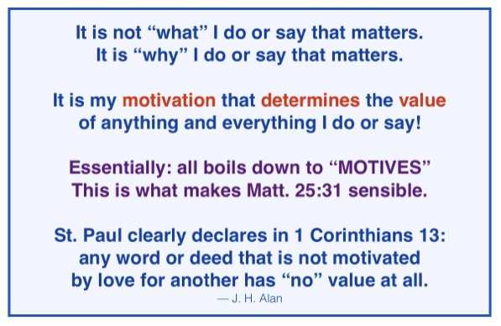

My Confirming Scriptures:

Aligning Experiences:

Volume 4, Day 26: A & P of Addiction part 5 of 5: SOLUTION
We have already talked about the STRESS of INSECURITY. So let’s look at the solution. The cycle begins with something that makes us recoil. It could be a tragic loss or simply what someone said. The sooner we release that particular event to God so that His Holy Spirit can handle it, the sooner we can stop raging. We can rely on God only when we trust His heart and nobility of purpose in all things. Don’t be fooled by the Devil’s lie, “God does only good things and the Devil does the bad ones.” God’s purposes are served by every thing, good or bad. As we hand the problem over to Him, we can relax instead of going to rehab. We then continue our routine, doing whatever comes next. And we know that there will be another stress not too far into the future. But this cycle produces the peace that passes understanding written of in the scriptures. Practice this cycle until peace remains your default state!
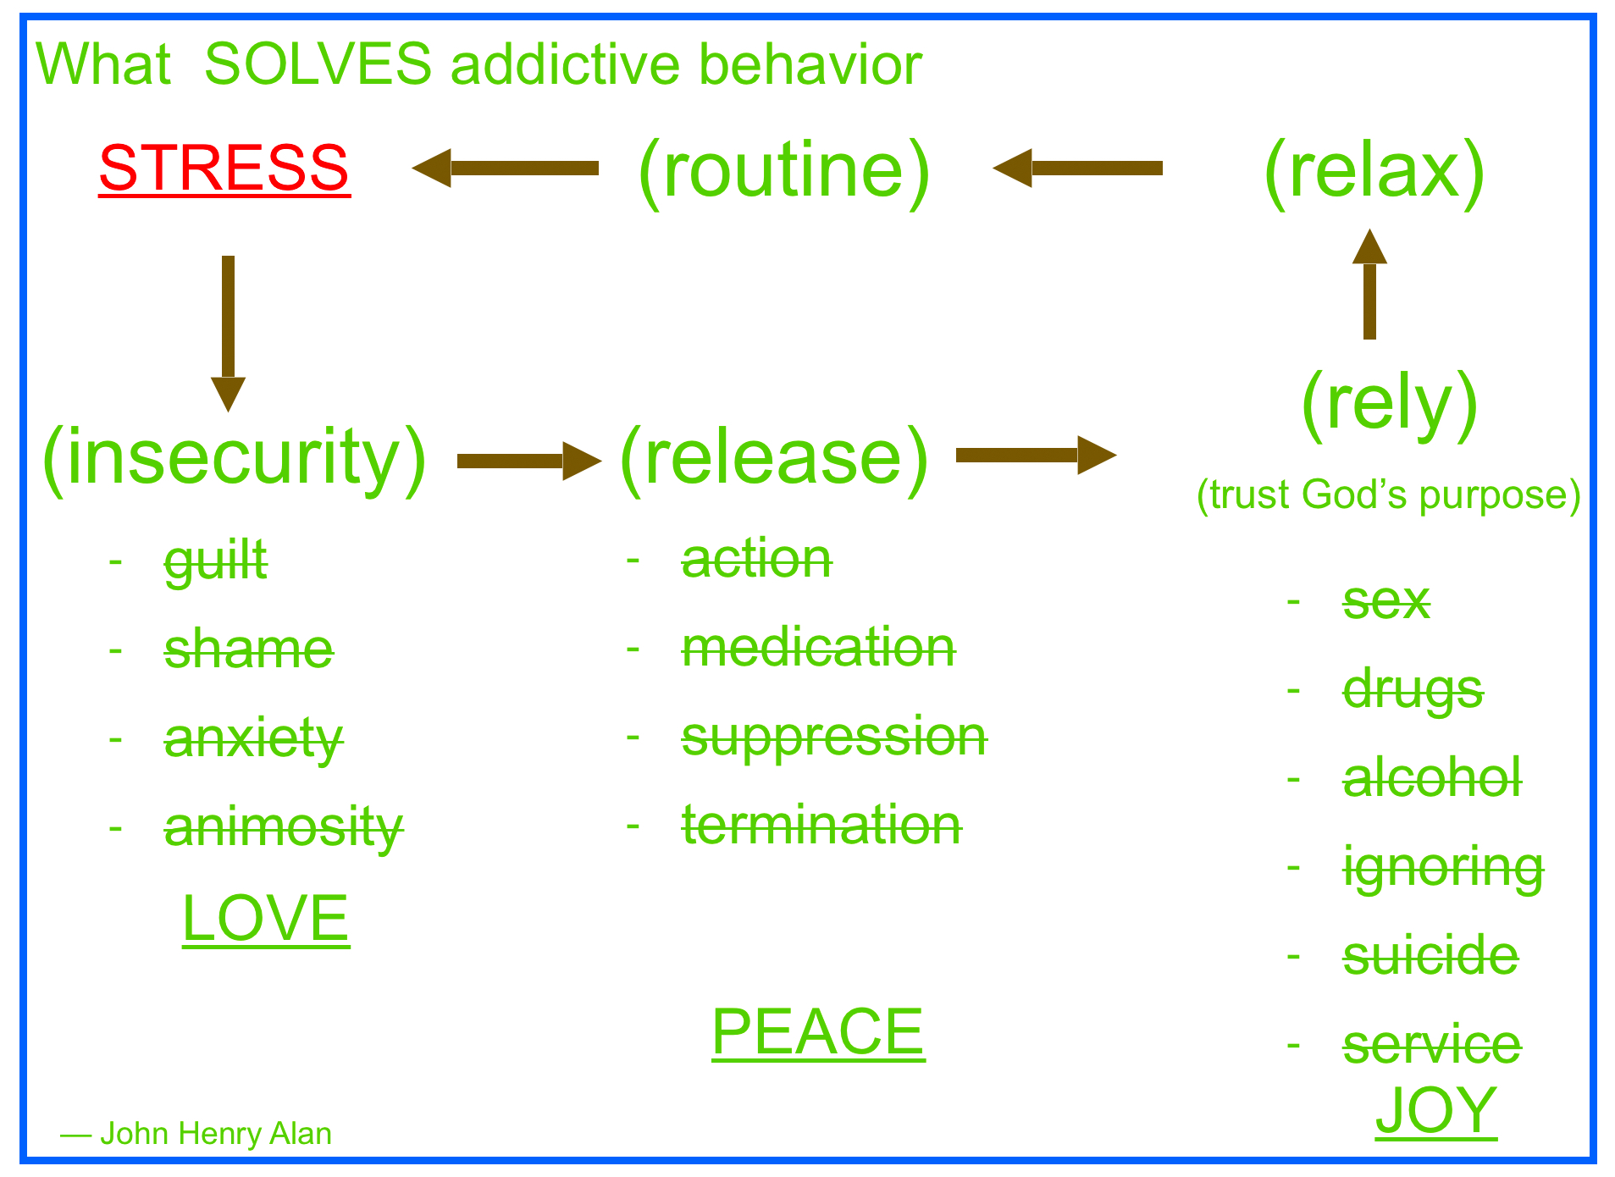
Volume 4, Day 27: The Holy Spirit’s Role in the Earth
Many pastors and teachers have been taught in their schools of theology about the role of the Holy Spirit on earth. Largely they teach us that the role of the Holy Spirit on earth is to convict humans of sin, righteousness and judgment! Christians the world around seem to speak this fluently. They also seem to believe it to be happening in their lives and claim that when they sin as a believer in Jesus that the Holy Spirit convicts them when they commit a sin. Unfortunately the Scriptures about the Holy Spirit do not bear this out! Having gone through deep theological training for over a decade, even I was misled in this regard. Let’s look again at John 16.
Jesus said to His disciples, “Nevertheless I tell you the truth; It is expedient for you that I go away: for if I do not go away, the Comforter will not come unto you; but if I depart, I will send him unto you. And when he is come, He will reprove the world of sin, and of righteousness, and of judgment: Of sin, because they believe not on me; Of righteousness, because I go to my Father, and ye see me no more; Of judgment, because the prince of this world is judged.
…when He, the Spirit of truth, is come, He will guide you into all truth: for He shall not speak of Himself; but whatsoever He shall hear, that shall He speak: and He will show you things to come. He shall glorify me: for He shall receive of mine, and shall show it unto you. All things that the Father hath are mine: therefore said I, that He shall take of mine, and shall show it unto you.” John 16:7-15 KJV:
In order to exchange my wrong beliefs which were taught to me by well-meaning and deeply trained (albeit misinformed) preachers, teachers and highly respected theologians, I had to trust the Holy Spirit Himself to guide me into God’s truth. And the more I abandoned wrong beliefs and trusted the Holy Spirit alone about His Own Word (the Bible), the more peace came upon me in my most difficult circumstances and the presence of very difficult people.

Volume 4, Day 28: Did Jesus Encourage Living Irresponsibly?
For many years I wondered why Mary was acting irresponsibly regarding the hospitality duties she had toward the guests in her home. I thought that Martha was perfectly justified in asking Jesus to send her sister in to help her with the kitchen in preparation for the community meal. Then in a very real and personal experience the Holy Spirit revealed to me the mystery of that story and why Mary and her story of irresponsibly sitting at the feet of Jesus was actually honored.
I had a supper gathering for ‘An Evening with God.’ We had a large crowd that night. I was preparing the meal and I had expected some to come assist me in the kitchen. That had been the usual pattern for these gatherings. At first I was frustrated because no one was offering to help. Everyone was milling about the living room chatting with each other.
I started to call one man to help me in the kitchen but I noticed he was talking to someone and it was obvious they were talking about something deeply spiritual. So I didn’t call out his name. I glanced around the room for someone else to ask. I saw one of the women speaking to someone else and rather than call out her name I paused in the same manner realizing that she and the people she was chatting with were also engaging in conversation with God. A few others came in but immediately seemed to join into conversation about God as well. So I kept silent and kept on working diligently on the meal. I cooked and served without help all through the meal. Although I missed the entire conversation at the dinner table, I was able to join in when everyone moved into the living room.
The Holy Spirit revealed to me that this was for me a reenactment of the meal at Martha and Mary’s home. He showed me that acting irresponsibly is appropriate when it is being responsive to God’s purposes. There is nothing more important than engaging God in relationship! Even Jesus’ disciples walked away from their co-workers and family members, leaving their duties behind for others to finish, in order to respond to Jesus’ call, “Come, Follow Me!”

Volume 4, Day 29: Elderly Spiritual Infants
I was visiting a large contemporary church a few years ago. Part of the service was dedicated to ‘showcasing’ spiritual maturity. The panel consisted of two elderly women who were interviewed by one of the pastors. One woman answered each question with a wisdom and insightfulness that compelled all to listen and learn. She obviously had memorized much scripture, knew Jesus well and loved Him dearly. The other woman was obviously spiritually ignorant. She lacked knowledge of scripture. And wisdom was obviously not in her. Yet both women had two things in common. One was old age. The other was relatively little evil being manifest in their lives. Consider this as well. If a glorious eulogy is given at an old woman’s funeral, it is likely to be believed and appreciated. If a similarly great eulogy is given at an old man’s funeral, it is highly likely that most of it will not be believed! And spiritual maturity is rarely even mentioned on such an occasion.
For some reason, we think that spiritual maturity comes with natural aging. This is like thinking that as rebellious young boy gets older, he will surely develop good behaviors. Yet, the truth be told, aging is a process of decay and decline and has little affect on behavior. So, why do we think that spiritual maturity accompanies aging? I believe that it comes from the false teaching that spiritual maturity is a matter of doing less evil and doing more kind deeds. Well, to be sure, most of us become less wicked when we get older, simply because our body cannot perform either rightfully or wrongfully in a particular activity (for example, sex). However, there is a correlation between less sinning and greater spiritual maturity. When one is truly in love with another they put the pleasure of the other ahead of their own. So, if one is spiritually mature, that is passionately in love with God, less selfishness and less relationally destructive behavior follow. Your behaviors either reveal your evil motives or confirm your pure ones. Spiritual maturity is selfless other-preferring expressions of unconditional love.
Volume 4, Day 30: “I am a Christian but I still have my rights!”
I cannot count how many times I expressed those words. And worse yet, the number of times I acted on those words even when they were not verbalized. Maybe you know someone who also believes those words.
One day as I was screaming silently that I have my rights, the Holy Spirit brought to my remembrance that Jesus never expressed that thought. He also never acted as though He had any rights at all.
I began to reread the Gospels and ponder the actions and words of Jesus. I wasn’t surprised to notice that Jesus gave up His rights the moment He entered our world. He emptied Himself of His rights, in order to become an example for us of serving His Father’s purpose rather than His own. And that purpose is “…that none should perish, but that all should come to repentance.” 2 Peter 3:9
The longer I meditated on the concept of giving up what is rightfully mine (rights given to me by God Himself), the more convicted I felt. Jesus, the Only Begotten Son of God, gave up the very thing each of us must give up in order to receive God’s salvation. I repented of my wrong belief, that I could be a Christian and still have my rights. I gave up my rights (to be in control of my own destiny) and gave them back to God.
The most amazing changes occurred in my soul each time I surrendered another right to God. Ultimately I realized that this is one of the keys to a life of peace. In retrospect, I could see how insisting on having it my way (my rights) had been, and always would be the source of conflict between me and others. My rights created expectations of others that were rarely met. And unmet expectations always made me angry.
As my beliefs changed, one by one, my love, joy and peace increased. As I began to move downward in order to lift others up on my back, I saw clearly how Jesus’ humility saves.

Volume 4, Day 31: Making a Point or Making a Difference
For as long as I can remember, I have participated in Bible Studies. The vast majority of them were mostly sparring with others about who knew the most or best things. They were information packing meetings intended to make us better Christians. But they were sorely lacking in the main thing. The primary message of the Bible is what to do in relationship and how to be in relationship. It was the how to that eluded me for years.
For over 40 years after becoming a Christian at age 14, I did Bible Studies in this manner. Yet in reflection of the overall effect my faith had on others, I clearly saw that I had made hundreds of points, but almost no significant difference. It was almost as though I had become a stick of petrified wood. Putrefied might be a better way to describe it. And my humiliation stimulated me to seek better ways to live and better interpret Scripture.
I went back to the Old Testament which was packed with rules for living and the consequences of breaking those rules. It also contained myriad stories that reinforced the value in the rules and compliance with them. And certainly without rules, civilized communities could not exist. But is community meaningful with obedience to rules alone?
I purposed to engage with others in Relationship Studies based Biblical truth. As the content of the studies shifted to affection for one another rather than comparing notes, so did the affection. We become more caring toward each other. And we began to notice that the good things we did for each other made a significant difference in how we loved each other. Jesus taught us to do for others because we love them, not out of obligation or duty.
It is love that makes the difference in our eternal destiny and in life. People know when they are the object of a project (charity) rather than the object of true affection. “Love Like Jesus Loves” and you will most certainly make a significant difference.

Volume 4+ Mercy, Forgiveness and Grace: Expressions of Love
Reflecting on the stolen silver scene in Les Miserables where the Bishop offered not just mercy and forgiveness but added grace (more silver to the thief), I decided to reread the whole Bible with ‘fresh’ eyes. Reading the entire Bible from the perspective of God’s mercy, forgiveness and grace, which are byproducts of His unconditional love for every human being, changed many of my misperceptions of God. My new perceptions changed my lifestyle as well.
I discovered that the Old Testament was not just about sin, condemnation and judgment. It was about living in love. I found in story after story, especially the sordid stories, that God‘s grace was at work. I began to see the entire Bible as the most amazing love story ever. Consider the stories of Job and Joseph who experienced enormous adversity and misery. Yet they knew and loved God in a deeply personal way. They didn’t shake their fist at God in complaint, like I was so prone to do. They saw God at work promoting the glory of His love and trusted Him despite their own personal pain and misery. They were confident in God’s purposes.
When God confronted the first murderer, Cain, He showed him mercy and withheld his due punishment which should have been death. God even placed a mark of protection on Cain’s forehead warning all that God would do seven times worse to them than they did toward Cain. It isn’t that God doesn’t get angry about things that humans do that are evil. It is that God made us to love us and for us to love each other. God loves us like we love even our wayward children,
Let yourself revel in the love that God has for you. He wants to release you from your feelings of guilt, shame and fear by continuing to pour His love upon you. Your parents may not have been good at all, but don’t consider God as an imperfect parent such as human parents maybe. By simply believing that God Himself in the person of His Only Begotten Son, Jesus, paid the penalty for you. Forgiveness is simply letting God “pay it forward”(the penalty for your sins, which are crimes against relationship) to Jesus who paid for all sin.

